Assembly instructions

# 1. Metal Block

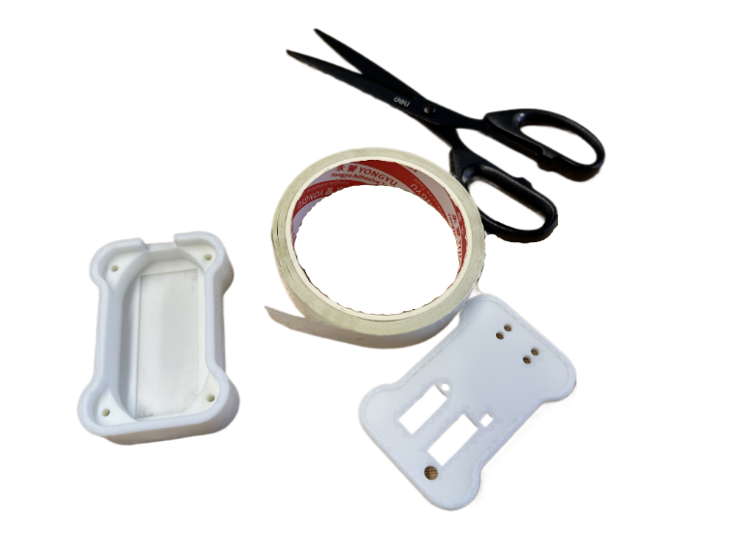Cut a strip of double-sided tape and glue it at the bottom of the 3D-printed case.

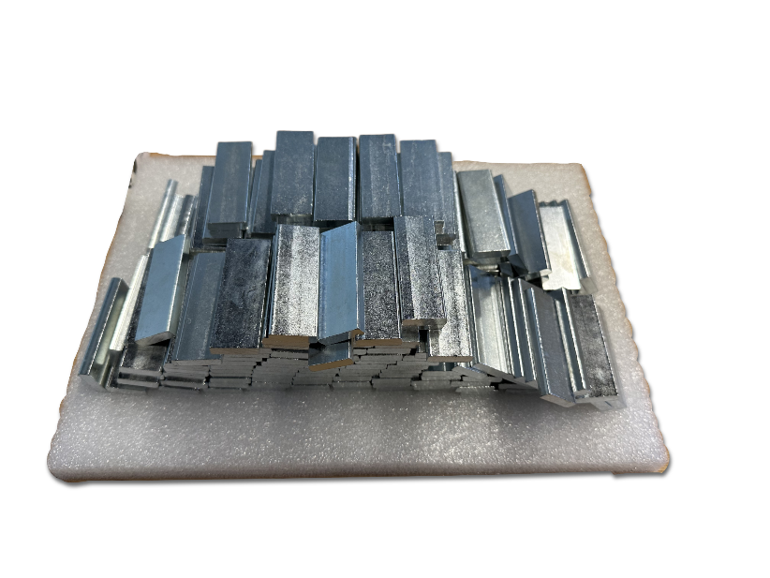

Then take a metal block and press it onto the double-sided tape:

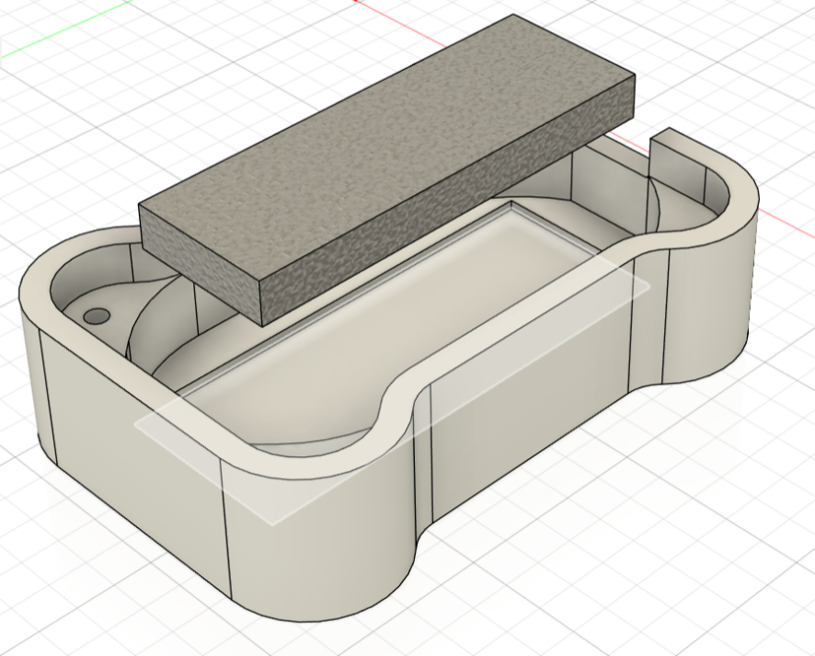

# 2. Place Board

Insert the circuit board in the 3D-printed case:

Do not use any screws at this point. The screws come in the end.

# 3. Flash Firmware

Download the **WCH-LinkUtility**. This is the software we’ll use to flash the firmware to the chip.

<https://www.wch.cn/downloads/wch-linkutility_zip.html>

Download **Google Chrome Remote Desktop**. This is the software you’ll use to connect to me, so I can take over your computer and do the firmware flashes.

<https://remotedesktop.google.com>

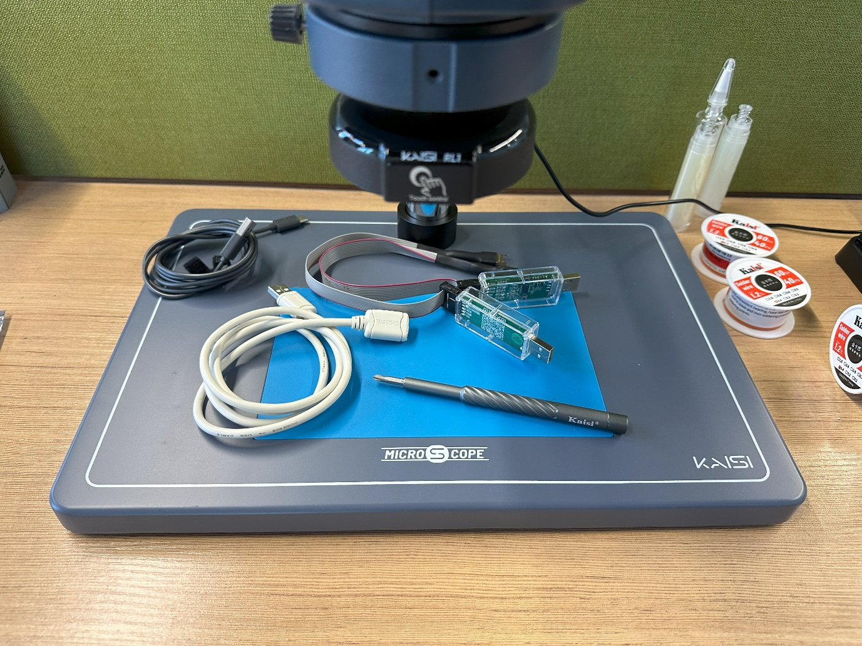

**USB Cable**

**WCH-LinkE**

**Flash Cable**

In the photo above, you can see three important items you need to flash the firmware to the chip:

1. 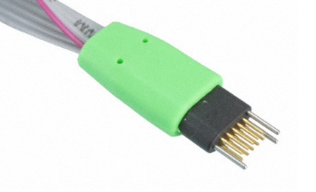**Flash Cable**: this cable ends in a “plug of nails” to make connection to the circuit board:
2. A green circuit board with black and white chips

   Description automatically generated**WCH-LinkE**: this device should be plugged into your laptop:
3. **USB Cable**: Plugging the WCH-LinkE device into your laptop directly can be challenging, because of the flash cable on the other side. Use this USB Cable for your convenience.

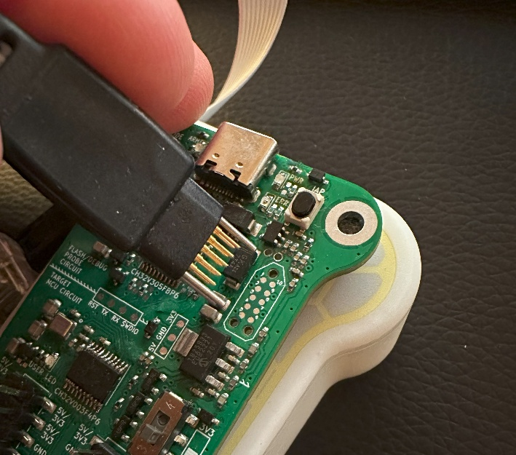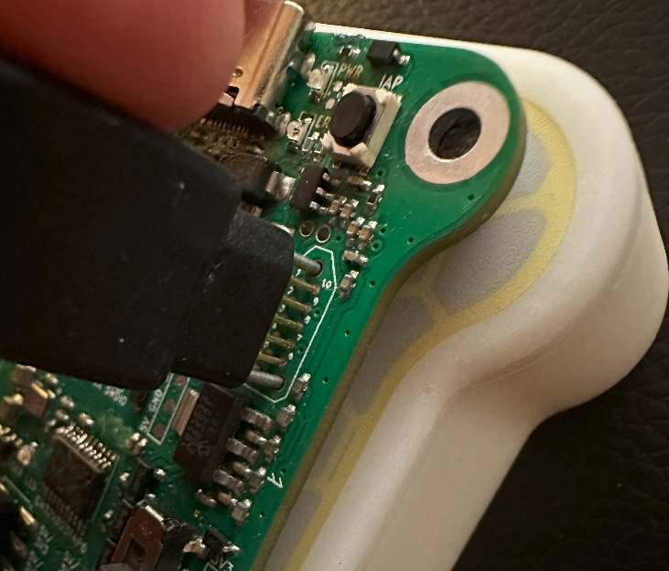Push the nails of the **Flash Cable** onto the **Circuit Board**:

In the figure above, the circuit board is taken out of the 3D-printed case. There is no need to do that (I simply didn’t have any other photo). Just leave the board inside the 3D-printed case while you push the Flash Cable on it.

Launch the **WCH-LinkUtility** software on your laptop. Then launch **Google Chrome Remote Desktop**. I will take over your computer for a moment and do the flashing for you. You need to keep the Flash Cable pressed onto the Circuit Board during the flash procedure.

# 4. Close the Solder Bridge

The circuit board has a **Solder Bridge** that must be closed *after(!)* you flashed the firmware. All you need to do is to place a blob of solder that makes the connection between both sides of the solder bridge. Be careful. Don’t apply too much solder, because then you might short-circuit other signals nearby!

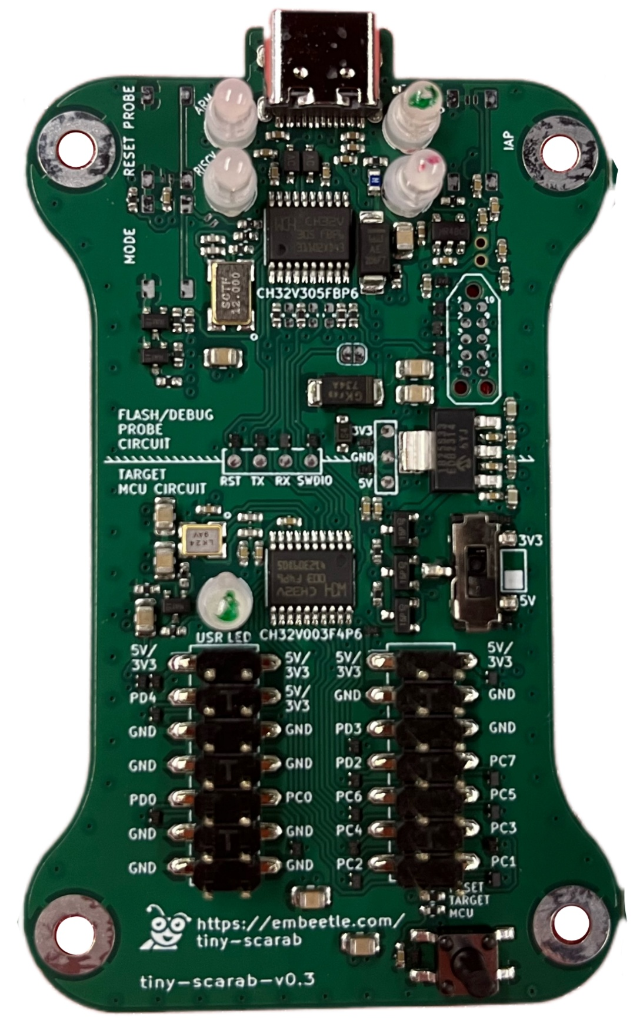

**Solder Bridge**

# 5. Close Lid and Glue Graphical Membrane

Close the **Lid** of the 3D-printed case. The Lid has openings for the LEDs. These LEDs should poke through. Then glue the **Graphical Membrane** on top.

**Lid**

**Graphical Membrane**

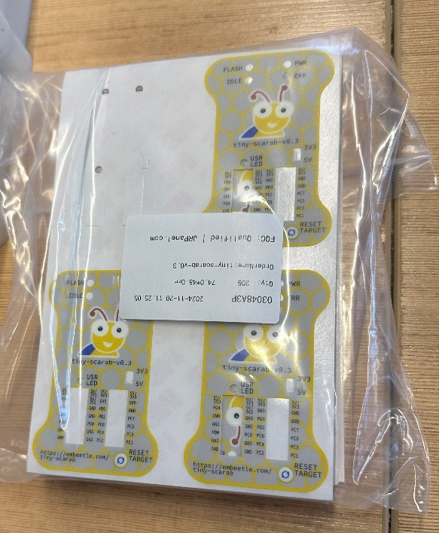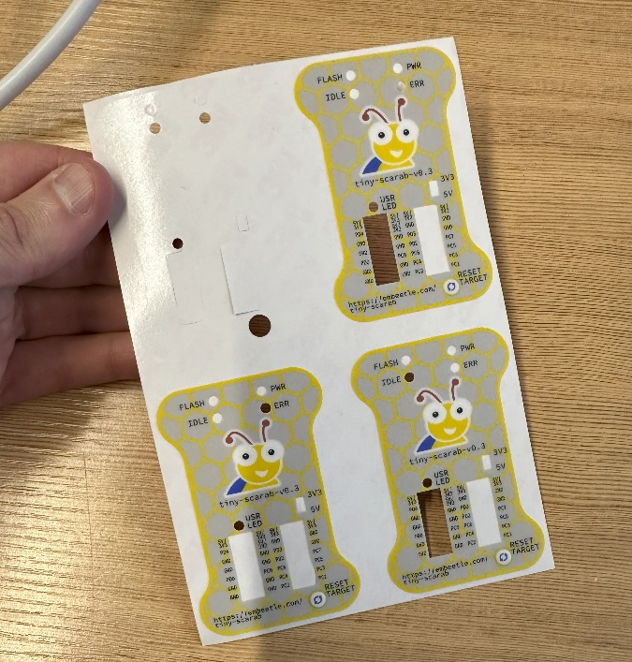You can find the Graphical Membranes here:

These Graphical Membranes are like stickers. Take caution when gluing them onto the lid! The LEDs should poke through the holes. Make sure everything is aligned properly.

# 6. Screws

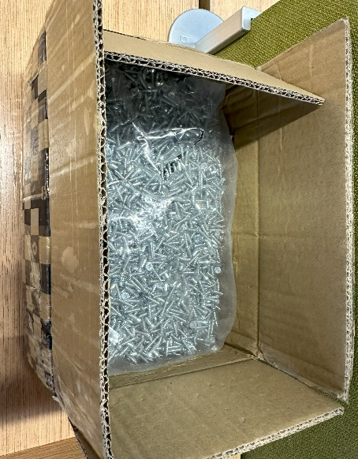Take four **screws** from the box and take the **Screwdriver**:

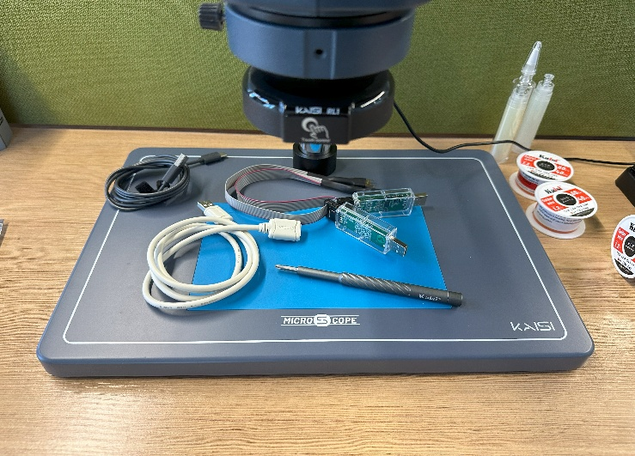

**Screwdriver**

**Screws**

Insert the four screws in the bottom of the 3D-printed case:

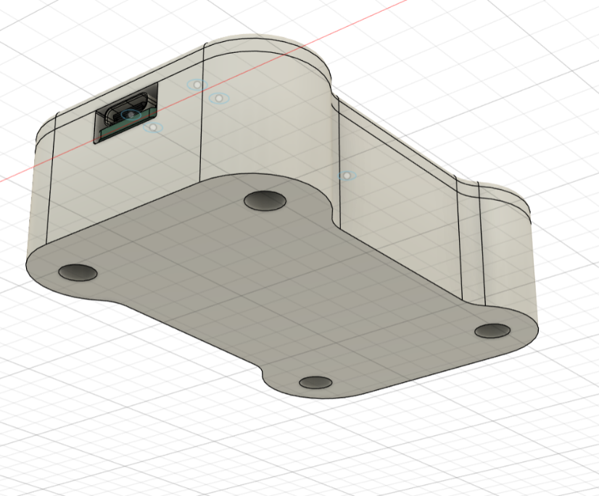

Screw until the lid is relatively fixed. DO NOT APPLY TOO MUCH FORCE! With too much force, the plastic will no longer hold the screw.

# 7. Packing

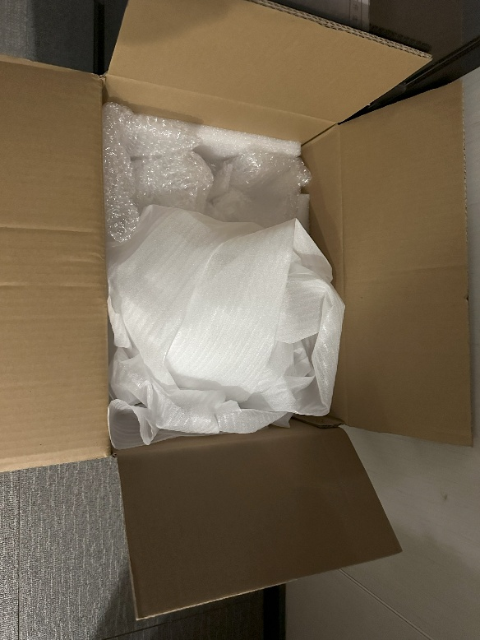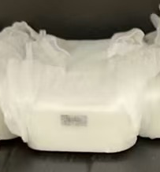Use the protective plastic (bubble wrap and the white foamy plastic) from this box, and wrap it around the 3D-printed case:

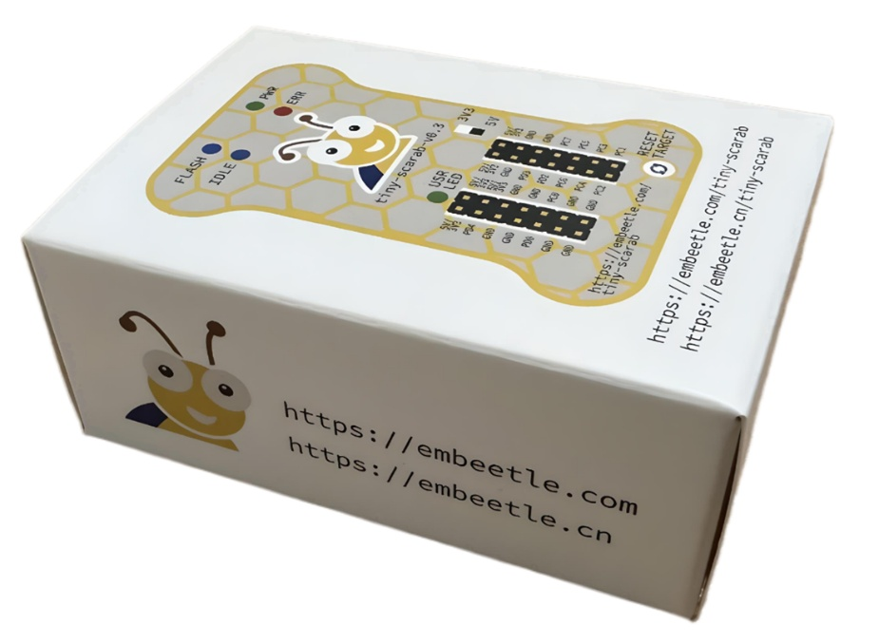Then shove the 3D-printed case into the cardboard box:

Last but not least: put some bubble wrap (or the white foamy plastic) around the cardboard box to protect it from damage during shipping.